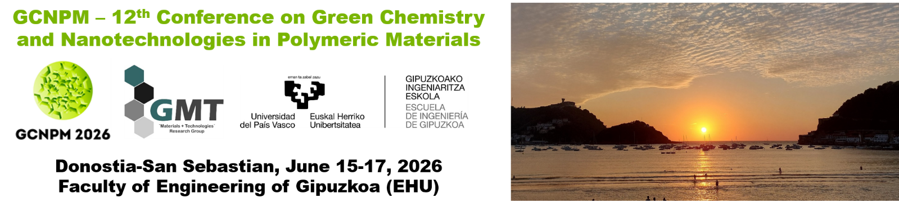
SPONSOR PACKAGES
 | GOLD (2500 EUR) | SILVER (1500 EUR)
Exhibition space | 10 m² | 8 m²
Full registrations | 2 | 1
Exhibitor badges | 2 | 2
Conference dinner | 2 | 1
Logo on program and Conference website | YES | YES
Logo placement in Conference hall | YES | YES
Advertisement in program | 10 lines (80-100 words) | 10 lines (80-100 words)
Distribution of company materials to all participants | YES | YES
Projection of advertisement before and between sessions | YES | YES
Demonstrations | YES | YES
Workshop | YES | NO

SPONSOR BOOKING FORM

SELECTED PACKAGE ___________________

Company name ______________________________________________________
Contact person _______________________________________________________
Street name _________________________________________________________
Post code ___________________________ City ____________________________
Country _____________________________________________________________
Phone number ______________________ Cell phone ________________________
Email address ________________________________________________________
Invoice email address (if different than above) _____________________________
VAT number _________________________________________________________

